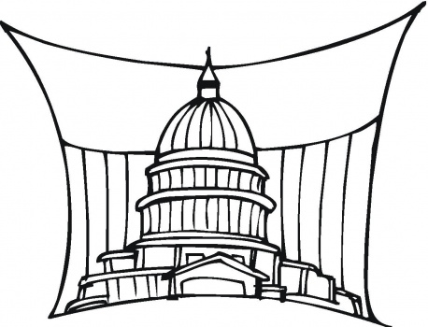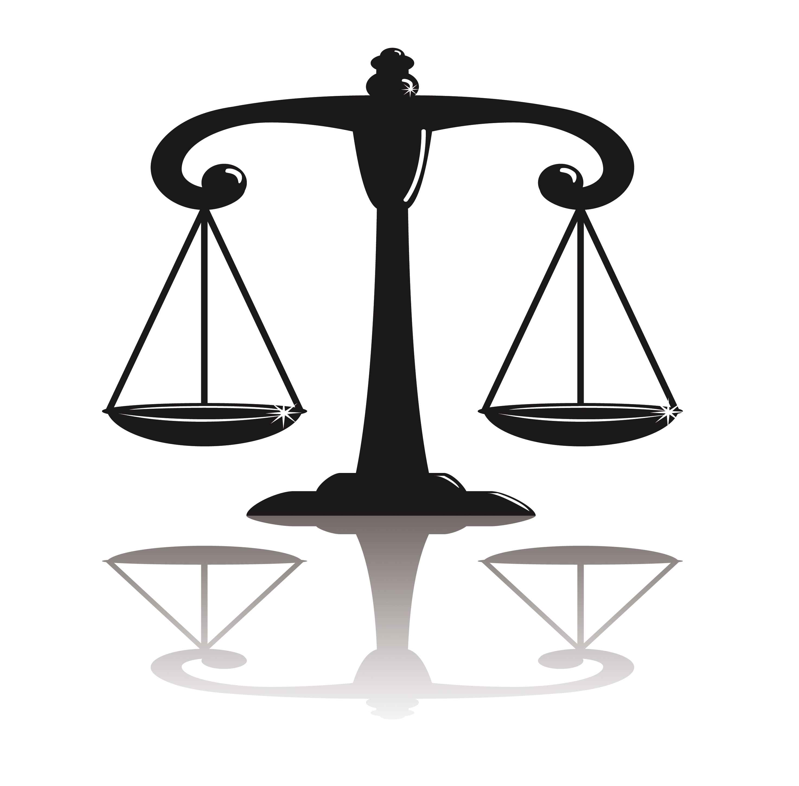
CAP Government
Mrs. Herrin

ASSIGNMENT TITLE: Public Policy Analysis
Choose an issue facing the United States right now. Then, explore the ways in which the government has addressed this issue using public policy.
Write an analysis in which you include the following components:
- Discussion of the current event issue
- Summary of the current public policy
- Current implications of public policy on society in the US
RUBRIC
PUBLIC POLICY ANALYSIS
Organization | Information is very organized with well-constructed paragraphs and subheadings.  5 points | Information is organized with well-constructed paragraphs.  4 points | Information is organized, but paragraphs are not well-constructed.  3 point | The information appears to be disorganized.  2-0 points
Understanding of the current event | Excellent understanding of the current event issue. Student clearly exhibits understanding of the background concerning the topic.  10-8 points | Good understanding of the current event issue. Student exhibits basic understanding of the background concerning the topic.  7-5 points | Some understanding of the current event issue. Student exhibits some understanding of the background concerning the topic.  4-3 points | Little understanding of the current event issue. Student does not exhibit an understanding of the background concerning the topic.  2-0 points
Understanding of the policy | Excellent understanding of the policy. Student includes many details about the policy and its current implications in the US. 10 -8 points | Good understanding of the policy. Student includes many details about the policy and its current implications in the US. 7-5 points | Some understanding of the policy. Student includes some details about the policy and its current implications in the US. 4-3 points | Little understanding of the policy. Student includes few details about the policy and its current implications in the US. 2-0 points
Mechanics | No grammatical, spelling or punctuation errors.  5 points | Almost no grammatical, spelling or punctuation errors 4 points | A few grammatical spelling, or punctuation errors.  3 points | Many grammatical, spelling, or punctuation errors. 2-0 points

